1. What are the ACID properties of transactions?

**The ACID Properties are:**

**Atomicity: all or nothing of the transactions effect will take place**

**Consistency: each transaction leaves the system in a consistent state**

**Isolation: each transaction must appear to be executed as if no other transactions are executed at the same time**

**Durability: the effect of a transaction must never be lost after the transaction is complete**

1. Consider Figure 2.10 in the “A First Course in Database System.”  Show a different way of representing the primary key.  What is the difference between declaring a key using “Unique” or “Primary key”?

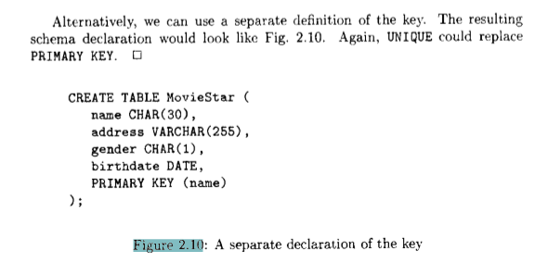

**Instead of PRIMARY KEY (name), we could utilize UNIQUE (name).  
  
The major difference between declaring a key using UNIQUE or PRIMARY KEY is that if PRIMARY KEY is used, none of the attributes in the tuple are allowed to be NULL. NULL is only permitted if using UNIQUE.**

1. Exercise 2.2.3 on page 29

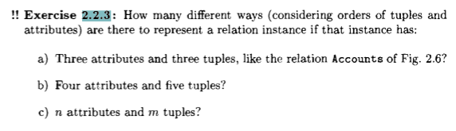

a) 3 attributes (ways to order) 3 tuples *(123, 132, 231, 213, 312, 321 = 6 ways OR 3!)* ways to order = 3!*3!   
= **36 different ways**

b) 4 att 5 tup = 4!*5! = **2880 different ways**

c) n att * m tup = **n! * m! different ways**